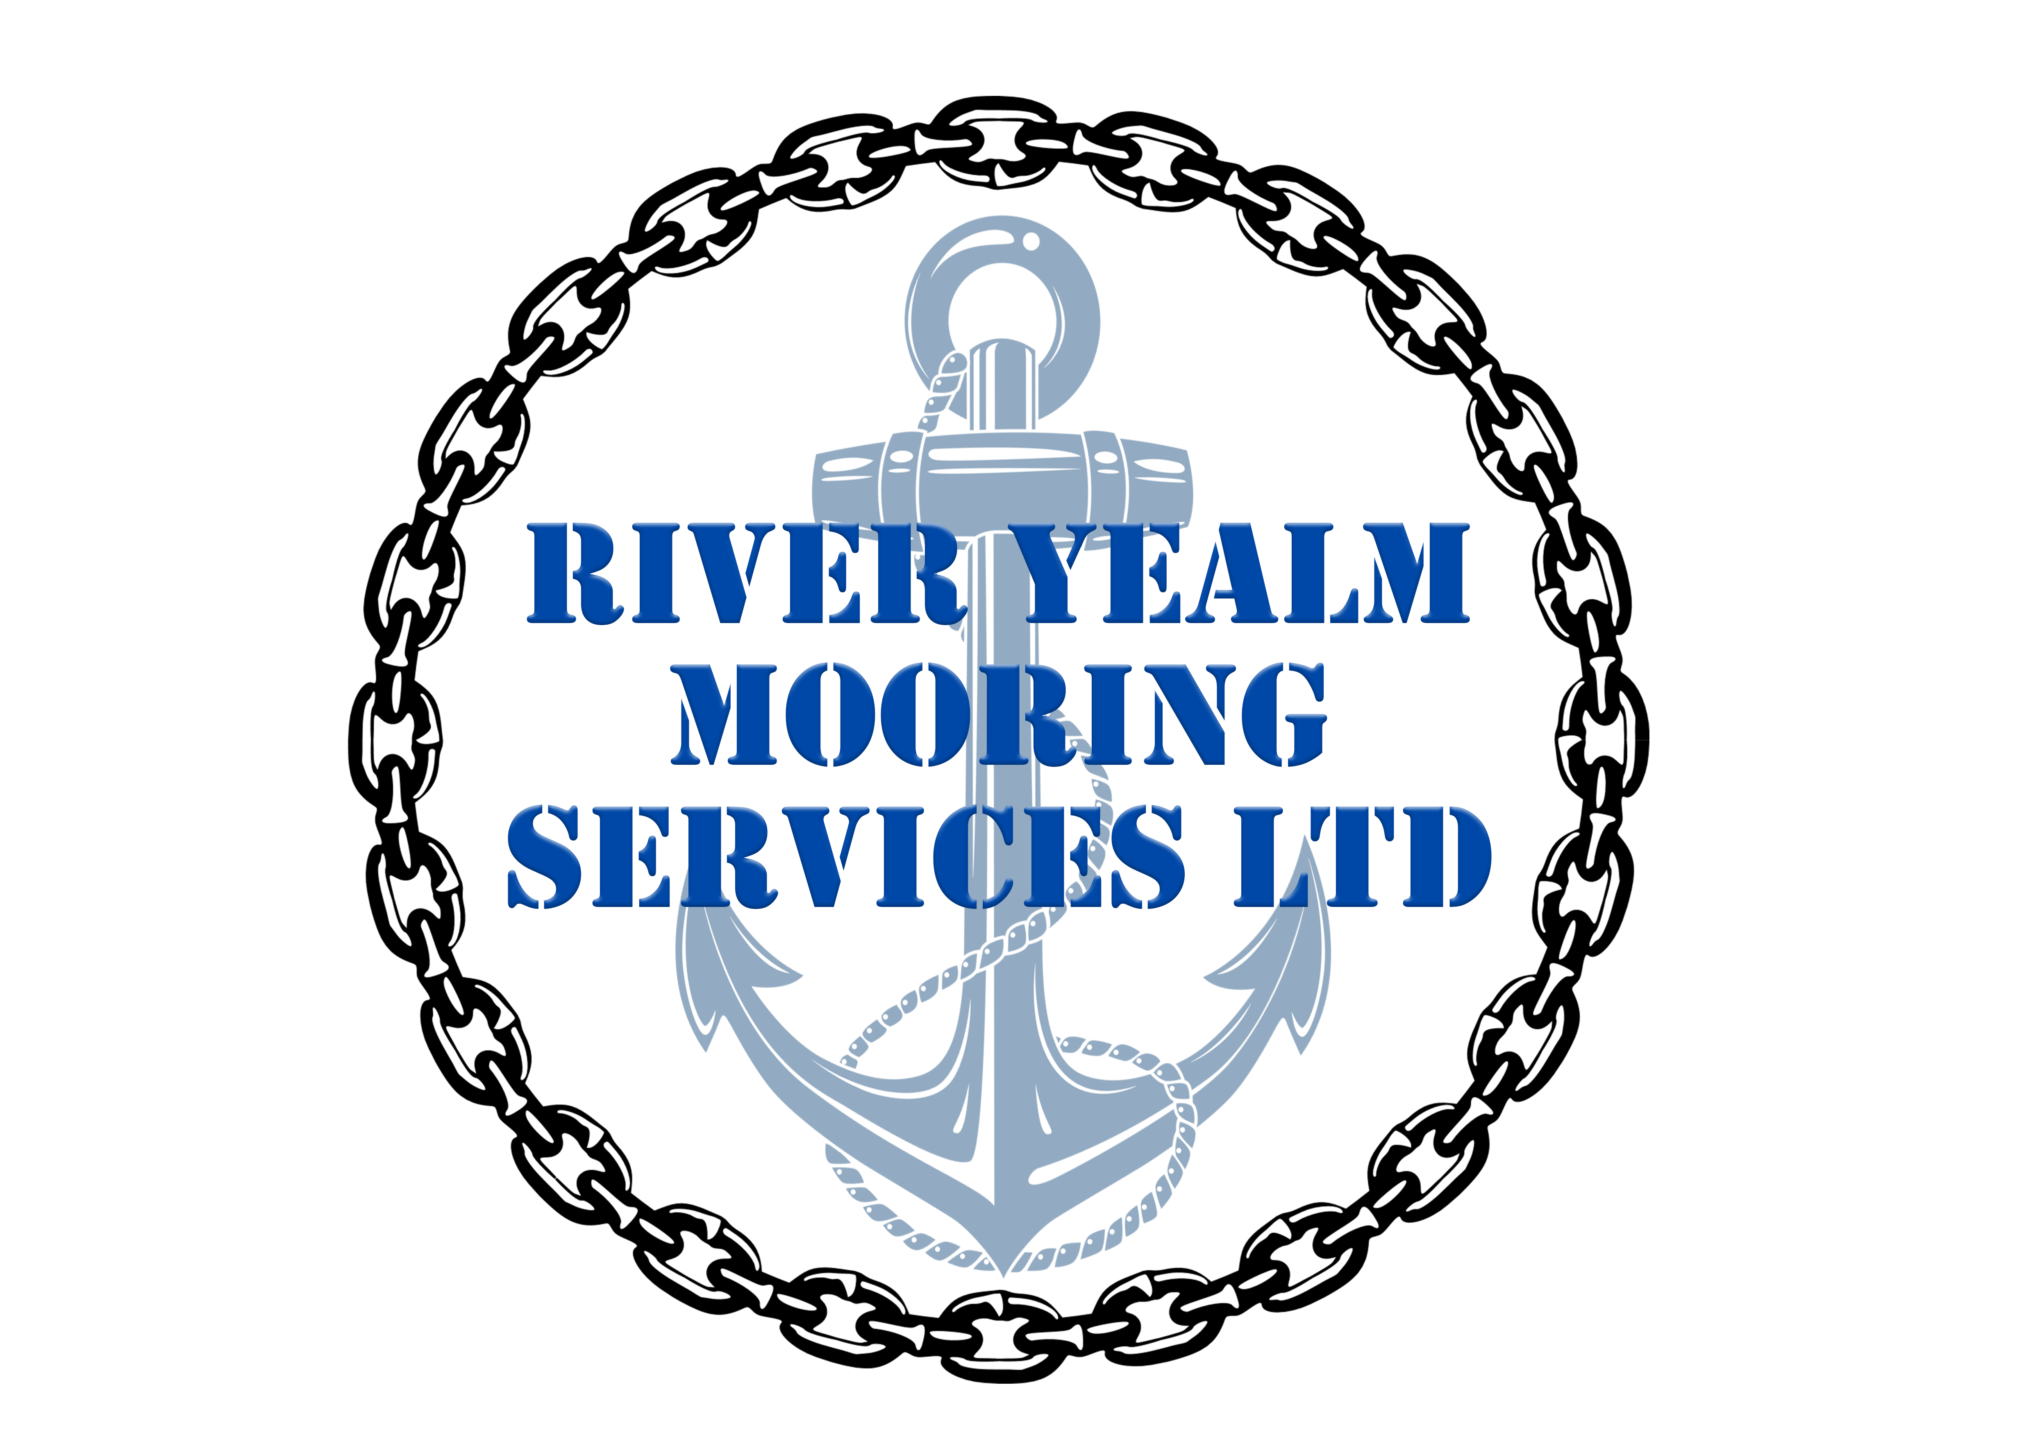

Mooring Inspection Service

River Yealm Mooring Services Ltd is a family business based in Noss Mayo operating, solely within the River Yealm. The business is operated by and employs local people, keeping the service delivery from within the Parish, as it has been ever since vessels were moored in the river.

Routine mooring inspections ideally occur between October and June. In order to undertake these inspections, Spring Low waters are required whereby the upper risers down to the top of the block chain are inspected. Once the upper accessible links of block chain are found to be giving dimension readings of below 16mm then the customer is notified that their mooring block and block chain has failed inspection and must come ashore.

On a neap tide the block is then lifted ashore utilising our lifting barge, whereby the block is inspected for concrete deterioration. If deemed of sound consistency, then the customer is offered a rechaining service for the mooring block.

This process involves cutting off the old block chain that had deteriorated past 16mm down at the staple / base link of the block that is embedded within the concrete, this will only be done if the base eye has retained a dimension of 25mm or above, if it has not then a fresh link is excavated on the next link down just below the concretes surface. A new U2 graded 32mm length of ground chain (breaking strain 84 Tonnes) is then shackled to this eye using a 13 Tonne green E pin safety shackle.
The mooring block concrete is then given a 5 year “life” after its return to position before it must come ashore again, or broken free from beneath the river bed with the lifting barge and dived accordingly for inspection.

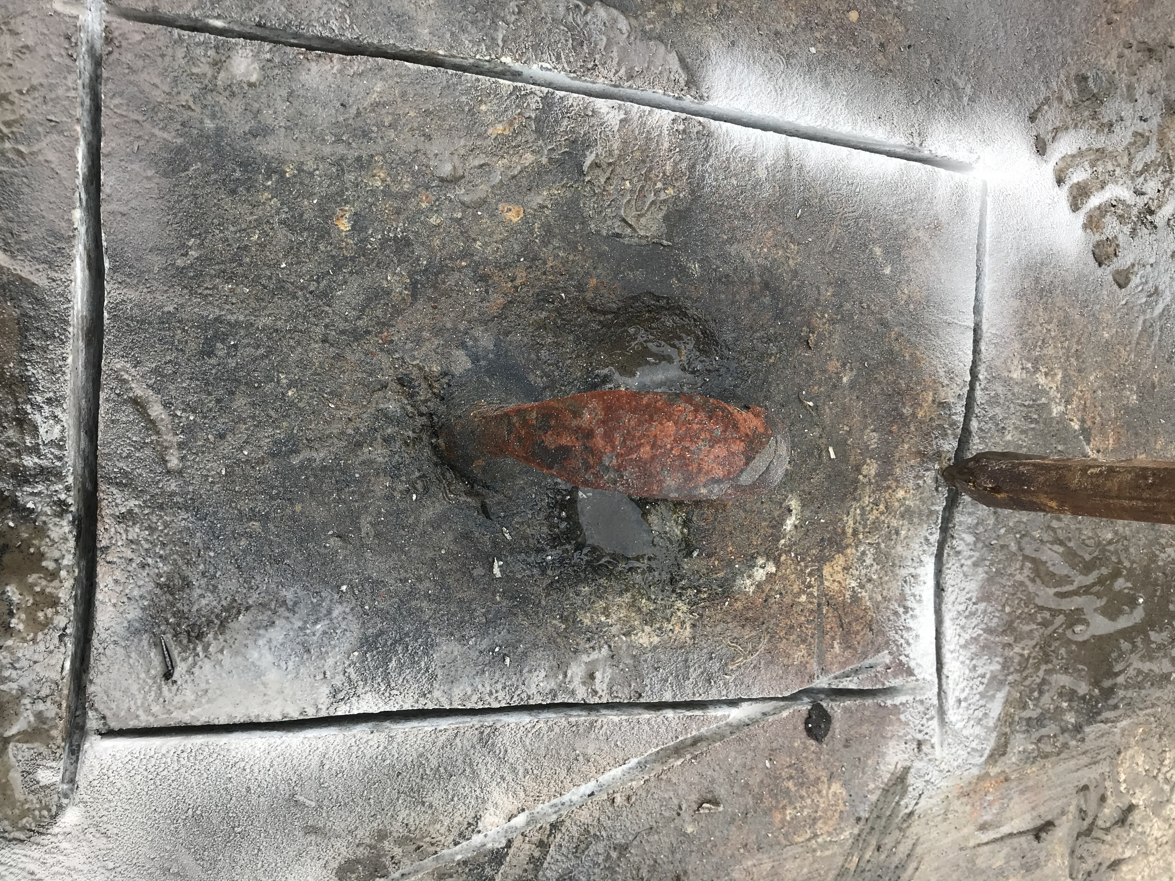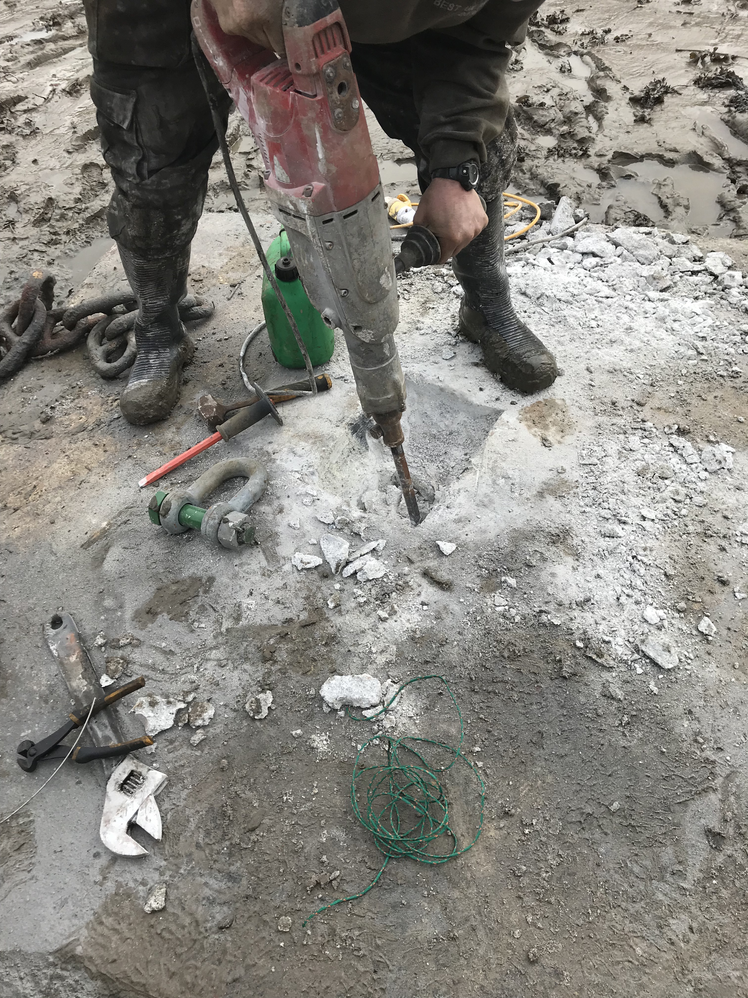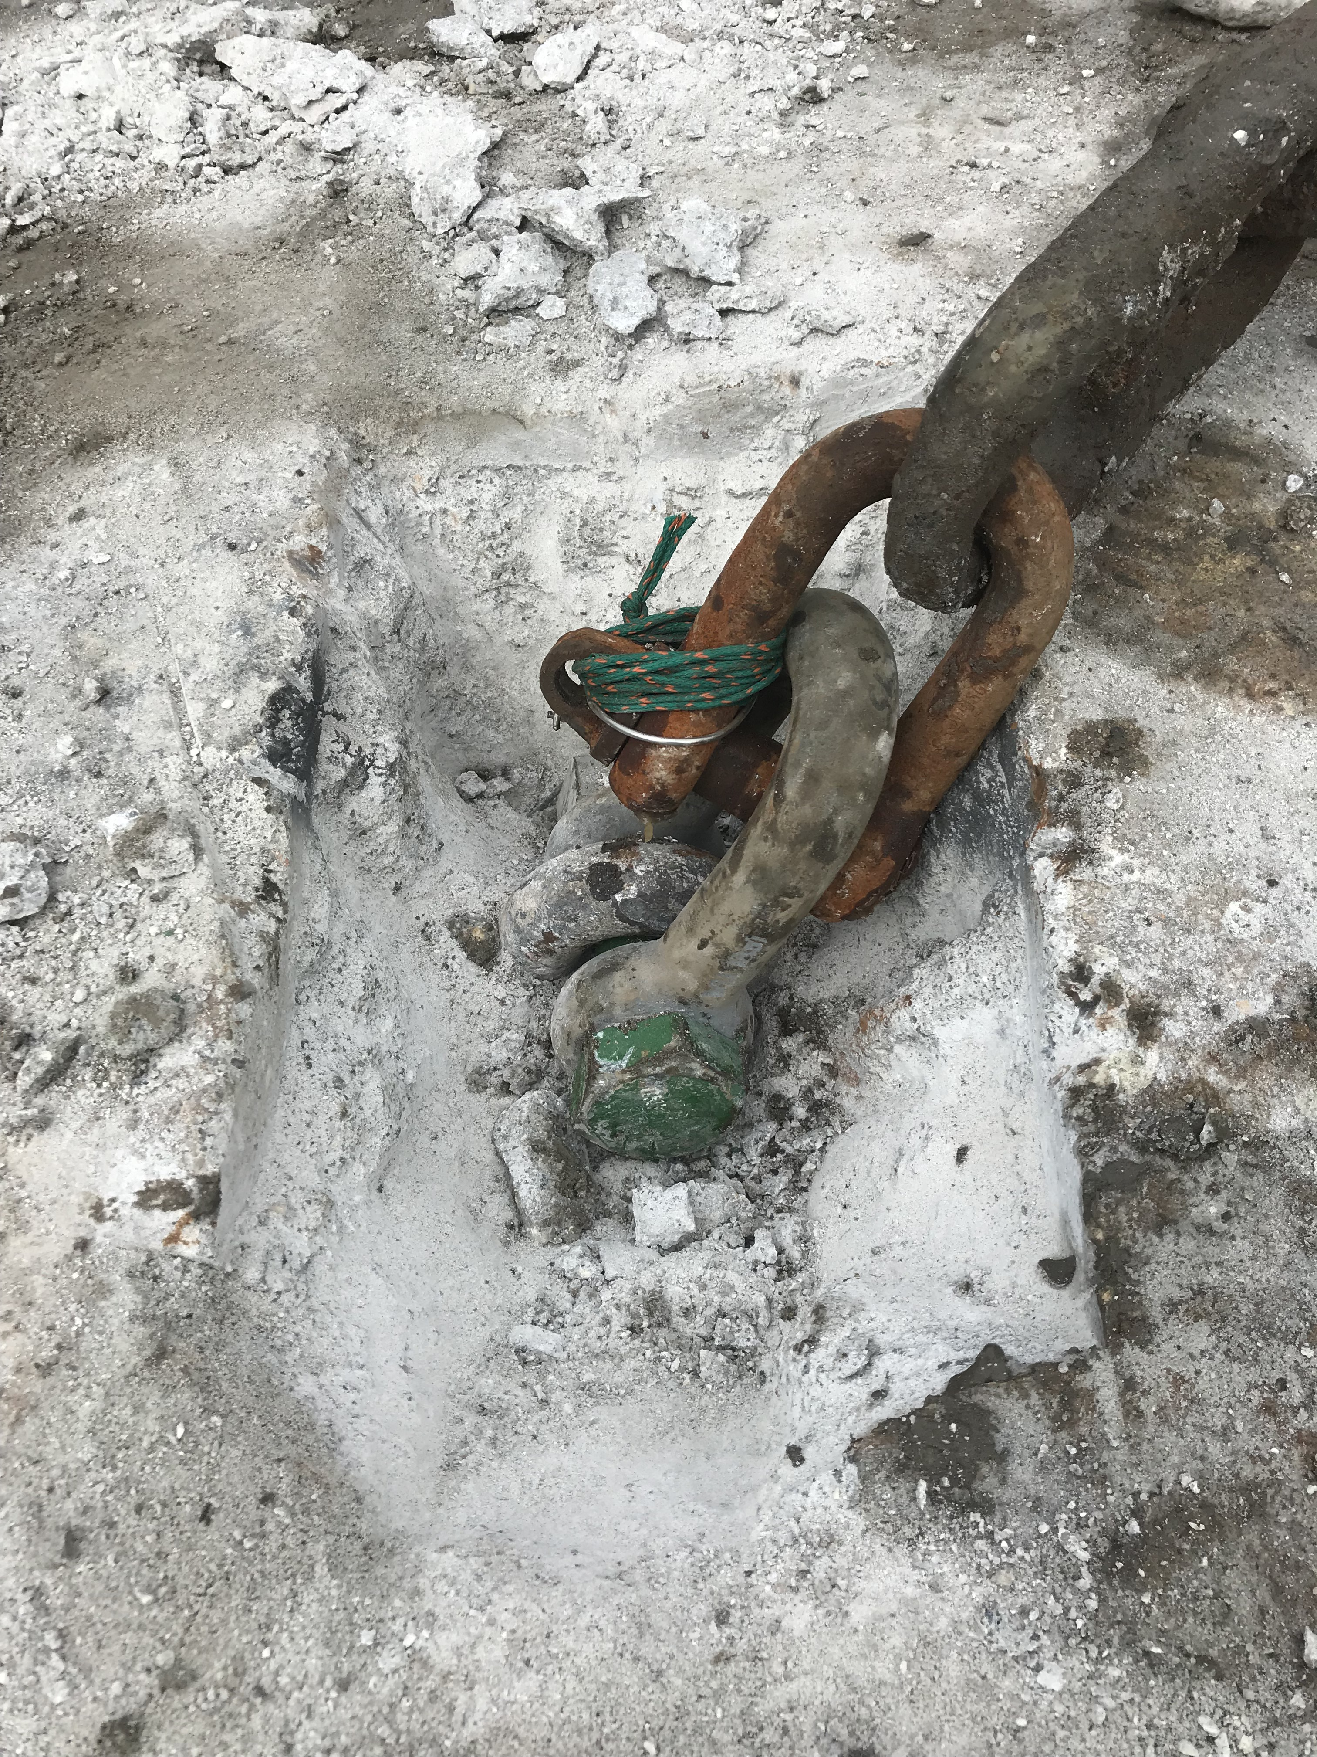

If the mooring block concrete is not deemed to be sound enough for refurbishment then a new 1.8m diameter x 200mm (weight 2 Tonnes) circular mooring sulphide resistant concrete block with a length of 38mm chain cast into it is offered as a replacement to their failed mooring block. This is then required to come ashore for inspection 10 years from date of siting into position.

The next component attached to the ground chain is a 25mm load tested shackle and then a length of 22mm galvanised riser chain (breaking strain 25 Tonnes). On average we are finding this component to last circa 4 years at present in the River Yealm before excessive corrosion pitting is identified. All shackles are greased and moused with 1mm stainless steel wire and nylon cordage.

Then attached to the end of this component by a 25mm load tested shackle is a 16mm (braking strain 16 Tonnes) or 19mm (braking strain 23 Tonnes) grade 316 Danish stainless-steel swivel which carries a supplier’s recommendation of 10yrs use sub surface. Since our inception we have begun a process of exchange for the majority of moorings to comply with this recommendation.

Then attached to this galvanised chain is a nylon codline rope riser with a 25mm load tested shackle into a hard eye whipped in, this is cleaned of marine growth and inspected for damage or abrasion. There is 10-year lifespan given to these mooring lines by the manufacturer and they attain a breaking load in excess of 8 tonnes.

Finally, then our recommendation is then to fit a hard eye to the top of the nylon rope riser and a 10mm galvanised pick up chain (braking strain 5 tonnes) is fitted with 12mm shackles. This is inspected for wear and deterioration, paying specific care to known wear points. Vessels fitted with rope pick-ups are cleaned at time of inspection and observed for damage however the onus of maintenance is put back onto the customer to keep continual note of their state of repair due to the rapid deterioration rope products can suffer.

A load cell has been utilised when breaking moorings free with our barge from the sea bed and no more than 2 tonnes has been recorded so far giving peace of mind that all components utilised have breaking strains far in excess of what it takes to lift a mooring block. Subsequently as all the mooring blocks have not be dragged about the Harbour over the last 30 years, we are happy that the products and procedures in place are fit for purpose within the River Yealm.

